**Name: Session:**

**Programming II**

**Lab Exercise 3.9.2023**

1. Create an application that displays payroll information. The application should allow the user to enter the following data for four employees:

* Number of hours worked
* Hourly pay rate
* Percentage withheld for state income tax
* Percentage to be withheld for federal income tax
* Percentage withheld for Social Security
* Percentage withheld for Medicare

The application should calculate and display the following data for each employee in a list box:

* Name
* Hours worked
* Hourly rate
* Gross pay
* Federal income tax withholdings
* State income tax withholdings
* Social Security withholdings
* Medicare withholdings
* Net pay

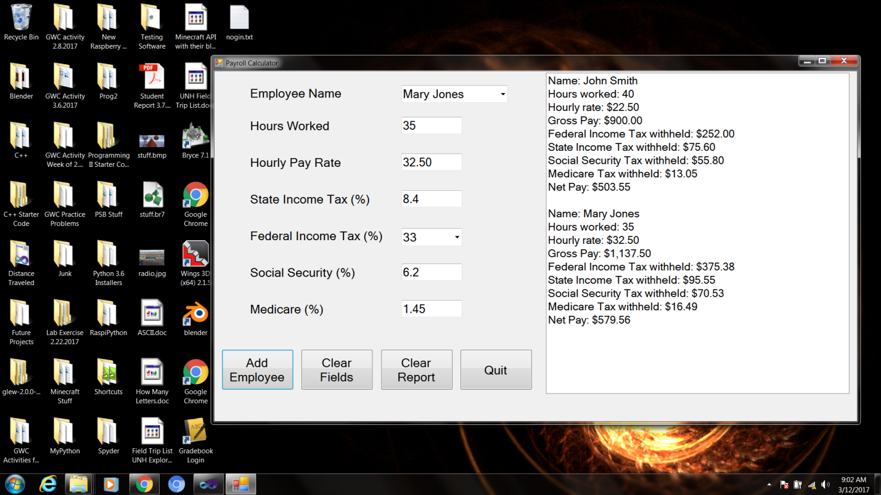

**When you have completed the application, Submit a screen shot of your running program as well as the source code.**